|  |
| --- |
| Solidarites_logoHor.jpg |
| Operator’s Manual |
| Sludge Treatment Site (STS) – Sittwe camp |
| **This document will be reviewed after each works and any definitive change in the operation of the STS**  **Last revision: 09/2020** |

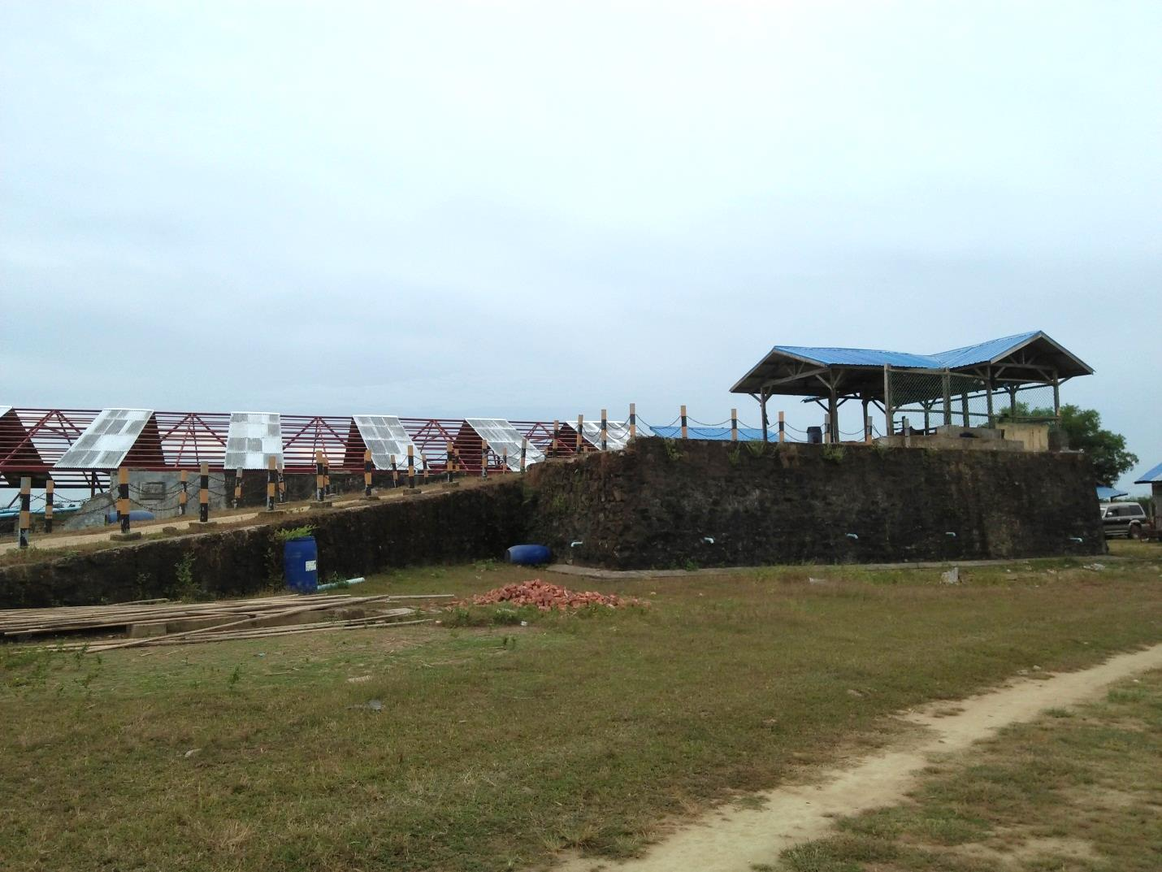

Contents

[2 Abbreviations 4](#_Toc50638015)

[3 STS history 5](#_Toc50638016)

[4 Technical description 8](#_Toc50638017)

[4.1 Overview of the STS 8](#_Toc50638018)

[4.2 FAECES LINE MODULES 11](#_Toc50638019)

[4.2.1 Dumping station 11](#_Toc50638020)

[4.2.2 Hopper Bottom Tank 12](#_Toc50638021)

[4.3 LIQUID LINE MODULES 13](#_Toc50638022)

[4.3.1 Anaerobic Baffled Reactor 13](#_Toc50638023)

[4.3.2 Constructed wetlands 1 14](#_Toc50638024)

[4.3.3 Maturation ponds 15](#_Toc50638025)

[4.3.4 Infiltration basins 15](#_Toc50638026)

[4.4 SLUDGE LINE (SOLID) 16](#_Toc50638027)

[4.4.1 Drying beds 16](#_Toc50638028)

[4.4.2 Dried sludge storage 17](#_Toc50638029)

[4.4.3 Incinerator 17](#_Toc50638030)

[4.5 SLUDGE LINE (LIQUID) 18](#_Toc50638031)

[4.5.1 Secondary constructed wetland 18](#_Toc50638032)

[4.5.2 Infiltration trenches 2 18](#_Toc50638033)

[5 Operation 19](#_Toc50638034)

[5.1 General 19](#_Toc50638035)

[5.2 Operation and maintenance procedures 20](#_Toc50638036)

[5.2.1 Dumping station 21](#_Toc50638037)

[5.2.2 Hopper Bottom tank 22](#_Toc50638038)

[5.2.3 Anaerobic Baffled Reactor 24](#_Toc50638039)

[5.2.4 Constructed wetlands 1 25](#_Toc50638040)

[5.2.5 Maturation ponds 26](#_Toc50638041)

[5.2.6 Infiltration basins 27](#_Toc50638042)

[5.2.7 Drying beds 28](#_Toc50638043)

[5.2.8 Secondary constructed wetland 30](#_Toc50638044)

[5.2.9 Infiltration trenches 31](#_Toc50638045)

[5.2.10 Dried sludge storage 31](#_Toc50638046)

[5.2.11 Incineration 32](#_Toc50638047)

[6 Monitoring plan 33](#_Toc50638048)

[6.1 Analysis planning 33](#_Toc50638049)

[6.2 Sampling instructions 34](#_Toc50638050)

[6.3 Other data monitored 34](#_Toc50638051)

[7 Health and Safety 36](#_Toc50638052)

[7.1 Health and safety measures 36](#_Toc50638053)

[7.2 Security measures 36](#_Toc50638054)

# Abbreviations

ABR: Anaerobic Baffled Reactor

AM: Activity Manager

ERF: Emergency Response Fund

HARP: Humanitarian Aid and Rescue Project

HBT: Hopper Bottom Tank

IDP: Internally Displaced People

OCHA: United Nations Office for the Coordination of Humanitarian Affairs

PM: Program Manager

RAT: Rapid Assessment Team

SI: Solidarités International

STS: Sludge Treatment Site

WASH: Water, Sanitation and Hygiene

TS: Total Solids

TSS: Total Suspended Solids

COD: Chemical Oxygen Demand

NO3: Nitrate

NH4: Ammonium

P: Phosphorus

# STS history

The construction of the STS was done under the supervision of John Fitzgerald, WASH PM. The site was found in September 2013, and the total size of the land is 120 000 ft2 (see document STS-Survey-Site 5.docx).

The land renters were compensated for the loss of agriculture up to 620,000 MMK (half the total amount going to each two land renters). The contract remains active for the complete period of working of the Sludge Treatment Site, and the payment covers the total losses with no further legal or financial obligations from Solidarités International (See document Land Compensation Agreement – STS vu JF).

The construction of the STS started in late December 2013 and was completed in March 2014. A contractor made it (contract MYA/HMSF/WAS/037/SIT/13 - supplier name Ko Mr. Ko Tin Hlaing), for 80,000,000 MMK (approx. 64,000 Euros). The contract was signed on 17th September 2013 with a delivery period of 60 days, but was delayed due to the site approval process (See document Explaination Letter\_final disposal site)

**The STS started operating in March 2014, and its first operational problems appeared less than a year later.**

**From July to December 2015, Manuel Kraehenbuehl (WASH AM) produced several documents regarding the STS:**

- 151008\_STS\_Assessment report\_final version

- 151026 STS work safety guidelines

- 151211 Instruction on lime treatment on the STS

- 151211 Lime for disinfection

- 151212 STS wastewater analysis

**In January 2016, a consultancy leaded by Elio de Bonis provided recommendations to improve the treatment performance and operation process (see document SI Sittwe Final Report).**

**Brice Pageaud (WASH PM) implemented some of the consultant’s recommendations (see document 201703\_STS activity form).**

**In 2018 and 2019, Marine Ricau (Sanitation AM) produced several documents regarding the operation of the STS:**

-Activity\_form\_STS\_June 2018\_update 0419

-CW cleaning and planting SOPs

-Drying beds cleaning SOPs

-ABR cleaning SOPs

-Maturation pond desludging SOPs

**In December 2018, Veolia Foundation did a mission to set up a laboratory in the STS and provided recommendations to improve the operation process (see document Technical Support Mission STS - SI Myanmar \_ EBA ROV 122019).**

**In February 2020, the Veolia Foundation carried out a mission to support SI in the implementation of the future upgrade (see document SHARED\_Field Support Mission STS - SI Myanmar \_ ADSH March2020).**

**At the same time Jules Gouron (Sanitation AM) implemented some of the consultant’s recommendations (see document SHARED\_Detailed Construction Recommandations V1\_ADSH).**

**In 2019 and 2020, Jules Gouron (Sanitation AM) produced several documents regarding the operation of the STS and future implementation:**

- Construction Workplan STS Upgrade V2 14 September 2020

- STS Operation Guideline (translated in Zawgyi and Myanmar)

- New version of maintenance task & operation task

- Map STS\_Jules\_new design

- **New version:** ANALYSES STS AUGUST 2020 Final V

- **All the drawings for future upgrade (including Hydraulic Profil)**:

**see:** https://drive.google.com/drive/u/1/folders/1SUXKAt2dLlupyhab3-yUABzRsIit6b-d

- Final report STS&Desludging15092020

- Methodology to sieve the sand for future Drying Beds

|  |  |  |  |  |  |  |
| --- | --- | --- | --- | --- | --- | --- |
| **2014** | **2015** | **2016** | **2017** | **2018** | **2019 (see STS log book)** | **2020** |
| **Ramp access** |  |  |  |  | Rehabilitation and elevation of the road access | New chain to protect the tractors against falls. |
| **Dumping station** | Rehabilitation of the roof | Removing of two baffles |  | Renewal of the solid sludge outlet pipe | Redesign of the reception channel | Installation of a protective fence to prevent any possible fall. |
| **Retention tank -> HBT** | Rehabilitation of leakages |  | Replacement by one HBT | Addition of a second HBT | Retention tank emptied | Paint for inside the HBT & improve Scum board by adding a bord |
| **ABR** |  |  |  |  | Cleaning of the gravels | Increase the number of desludging in the chambers |
| **Constructed wetlands 1** |  |  |  | Cleaning and sorting of gravels according to size | Rehabilitation of the Inlet & planting | Cleaning of the gravels |
|
| **Maturation ponds** |  |  |  |  | Installation of a gravel filter at the outlet (currently not used) |  |
| **Infiltration trenches 1 -> Basins** |  |  |  |  | Removing and installation of basins | Rehabilitation of Infiltration basins |
| **Drying beds** |  | Addition of two emergency drying beds | Pilot for two vertical filter planted bed |  | Cleaning the gravels and replacement of the sand from beds 2, 3 and 5 | Cleaning the gravels and replacement of the sand from beds 1, 4 and 6 |
| Roof rehabilitation |
| **Secondary Constructed wetland** |  |  |  |  | Cleaning and sorting of gravels according to size & Planting |  |
|
| **Infiltration with gravels** |  |  | Replacement by infiltration trenches 2 |  |  | Rehabilitation of Infiltration pipes |
| **Dry sludge storage** |  |  | Addition of two storage boxes |  | Rehabilitation of one wall | Construction of 5 new rooms |
| **Incinerator** |  |  |  |  |  | Installation of the Chimney extension and construction of a second incinerator |
| **Laboratory** |  |  |  | Set up |  |  |

Figure 1: Construction chronology of STS modules by year

# Technical description

## Overview of the STS

The Sludge Treatment Site (STS) is operating since 2014. It treats the fecal sludge from about 90 000 IDPs of Sittwe camps, 6 days a week. Several improvements were made over the years, to reach its current functioning. The fecal sludge is pumped from the pit latrines into a 1.5m3 plastic tank, which is then transported to the STS by tractors.

At the STS, the plastic tank is emptied into the reception tank of the dumping station where the volume is measured. The sludge is then directed into two hopper bottom tanks that work in parallel. There the sludge settles and is separated between a liquid and a thicker part. The liquid part goes to the anaerobic baffled reactor, where the biodegradation of organic material happens thanks to the microorganisms contained in the settled sludge. It then goes to the horizontal flow constructed wetlands, where the particles are filtered out and the microorganisms further degrade the organics. The wastewater then goes into the maturation ponds, where it is treated by natural occurring processes and the influence of solar light, wind, microorganisms and algae. It is then infiltrated into the ground through infiltration basins. The thicker sludge that has settled into the hopper bottom tanks is diverted into the drying beds, where the water is drained through the sand and gravels to the bottom of the bed, and evaporation happens at the surface of the sludge. The liquid drained then goes through a horizontal flow constructed wetland and infiltration trenches. The dried sludge remaining on top of the drying beds is removed manually and stored into storage units to further dry. It is then incinerated and the ashes are given to farmers as soil amendment.

Solid

Liquid

Liquid

Solid

Figure 2: Current Treatment System Overview

Liquid

Solid

Liquid

Liquid

Solid

Solid

Solid

Liquid

Solid

Figure 3: New Treatment System Overview

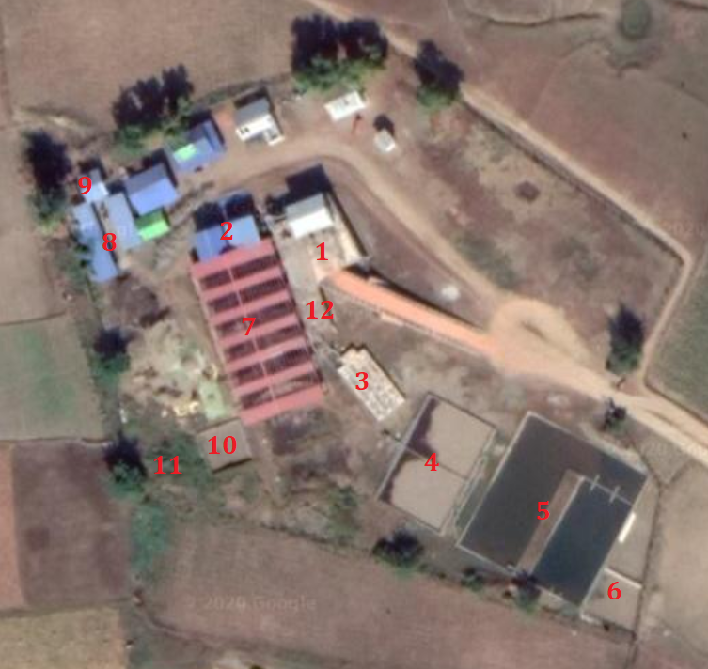

Figure 4: STS Map

## FAECES LINE MODULES

### Dumping station

The dumping station is the first module of the STS where the tractors empty the plastic tank at the rear by means of a valve at the bottom. The dumping station is composed of two emptying concrete tanks where the plastic tank is emptied, of a screen to remove the solid waste, of a channel and of an outlet tank where the scum is trapped. The volume dumped is measured with a wooden stick and recorded in a notebook. It’s then recorded in Weekly “SitRep” report.

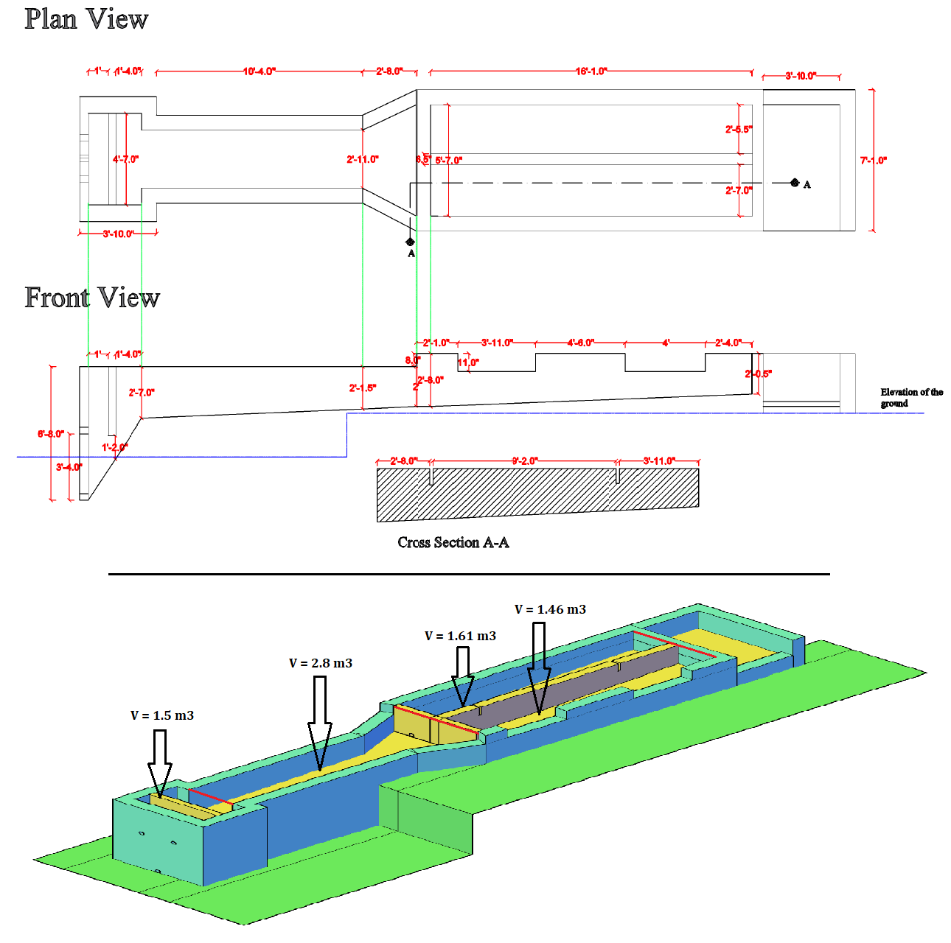

Figure 5: Design Dumping Station

Main Objective & Reduction at the Dumping Station

### Hopper Bottom Tank

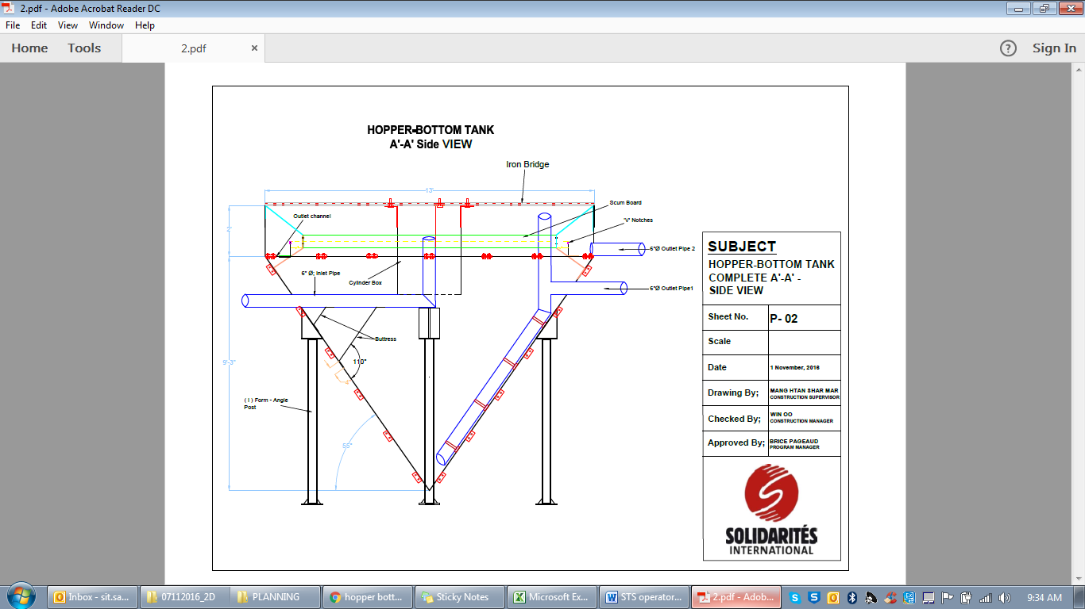

Figure 6: Drawing of the functioning of the hopper bottom tank

The Hopper Bottom Tank (HBT) is the second module of the STS. It provides mechanical primary treatment which consists mainly of sedimentation and flotation of inorganic material (biological degradation of settled solids occurs partly). The HBT is in a cone shape, with the sludge entering at the top inside a cylinder box to prevent the disturbance of the scum. The solids and sludge settle and accumulate at the bottom while the scum (lightweight materials like fats and greases) rises to the surface. A scum board prevents the scum from flowing into the liquid outlet pipe. The solid outlet pipe reaches from the bottom and the solids flow out with hydraulic pressure.

The aim of the HBT is to reduce the Total Solids (TS) content from the faeces in order to dry it on Drying Beds. Note: TS not to confuse with Total Suspended Solids (TSS)

Main Objective & Reduction in the HBT

## LIQUID LINE MODULES

### Anaerobic Baffled Reactor

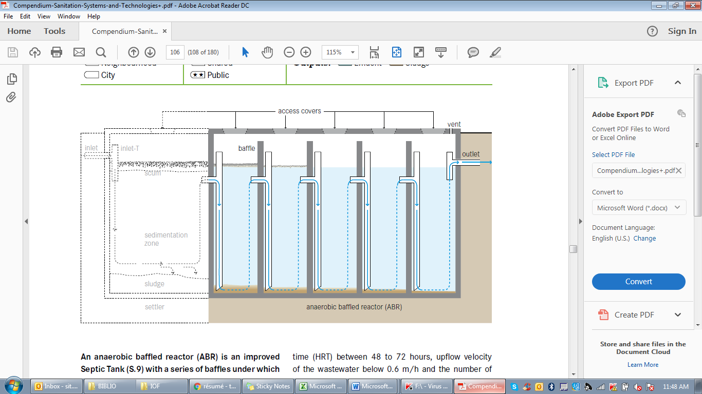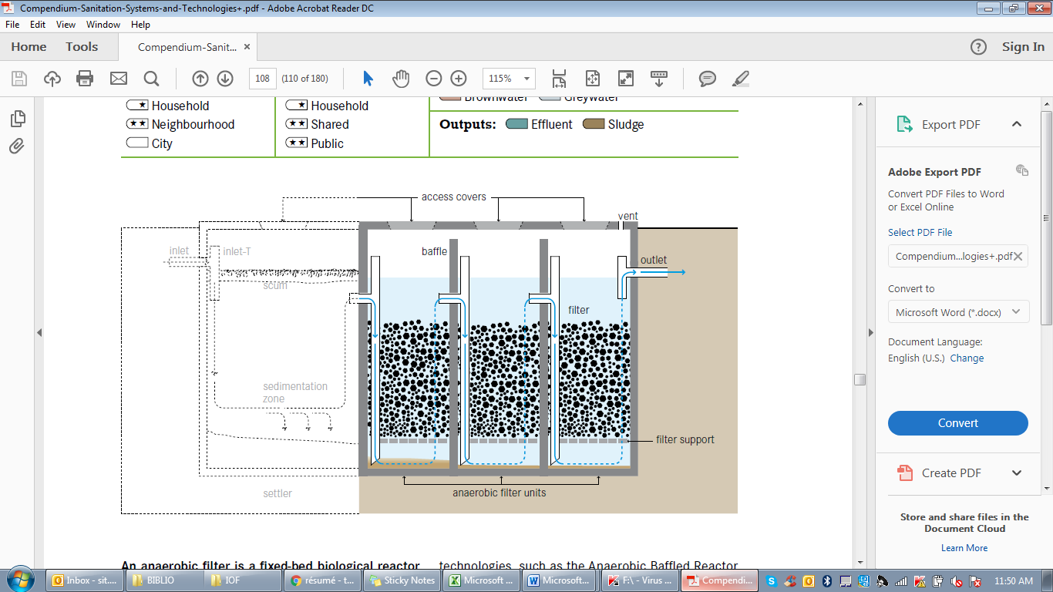

Figure 7: Drawing of the functioning of the ABR

The Anaerobic Baffled Reactor (ABR) is the first module of the STS wastewater treatment line. It provides biological secondary treatment which is the biodegradation of organic material by the micro-organisms contained in the settled sludge. The ABR is divided into 4 rows of 12 successive chambers each, with two common inlet chambers and one common outlet chamber. Three parallel down pipes are located at the inlet of each chamber, leading the incoming flow toward the bottom of the chamber. The inflow is forced to pass through the activated sludge where anaerobic bacteria are feeding from the organic material contained in the inflow to be treated. The last four rows of chamber contain a filter media, and thus act as an anaerobic filter, or a fixed-bed biological reactor. As wastewater flows through the filter, particles are trapped and organic matter is degraded by the active biomass that is attached to the surface of the filter material.

The aim of this step is to reduce the Chemical Oxygen Demand (COD). Pollutant sediment at the bottom and is pumped to be dried on the Drying Beds.

Main Objective & Reduction in the ABR

### Constructed wetlands 1

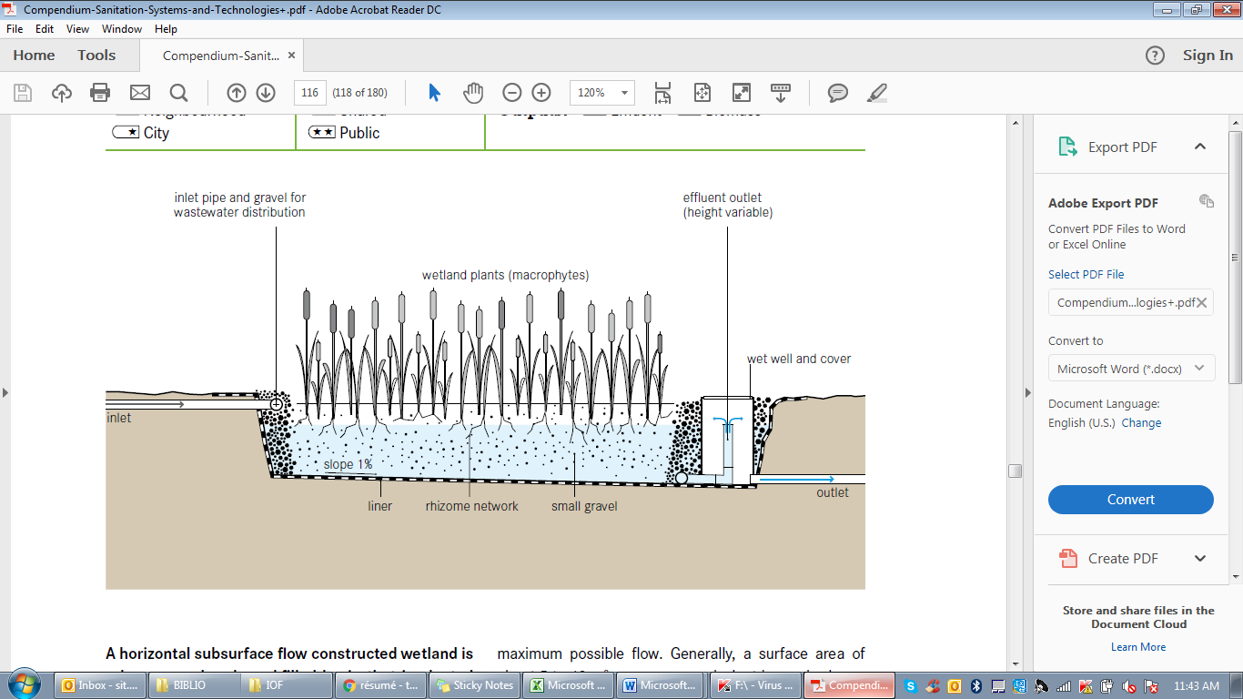

Figure 8: Drawing of the functioning of a standard constructed wetland

The horizontal flow constructed wetlands are the second module of the STS wastewater treatment line.

It consists of two large gravel and sand-filled basins (that are planted with wetland vegetation). As wastewater flows horizontally through the basin, the filter material filters out particles and microorganisms degrade the organics. The filter media acts as:

* a filter for removing solids,
* a fixed surface upon which bacteria can attach,
* and a base for the vegetation.

Although facultative and anaerobic bacteria degrade most organics, the vegetation transfers a small amount of oxygen to the root zone so that aerobic bacteria can colonize the area and degrade organics as well. The plant roots play an important role in maintaining the permeability of the filter.

The pre-treated wastewater from the ABR is loaded continuously onto the surface of the HFCW through perforated pipe system. The water flows horizontally through the filter layer to the other bottom side of the bed where it is collected in a drainage pipe system. The wastewater is treated by a combination of biological and physical processes.

The aim of this step is to reduce the TSS, COD, Nutrients (NO3; NH4) & Phosphorus (P).

Main Objective & Reduction in the CW1

### Maturation ponds

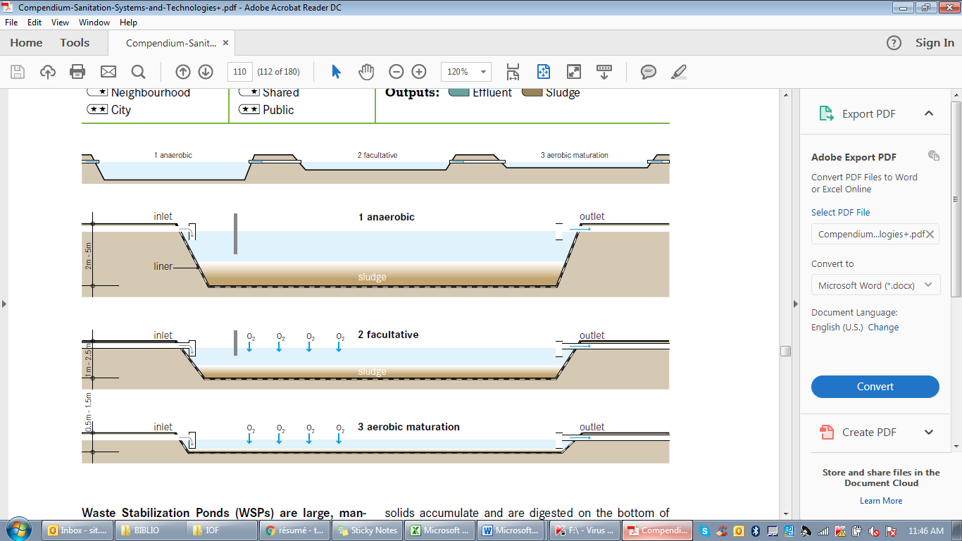

Figure 9: Drawing of the functioning of the stabilization ponds

The maturation ponds are the third module of the STS wastewater treatment line. It consists of two large, man-made water bodies in which fecal sludge is treated by natural occurring processes and the influence of solar light, wind, microorganisms and algae.

Algae growing on the surface provide the water with oxygen leading to aerobic oxidation of the organic pollutants. Due to the algal activity, pH rises leading to inactivation of some pathogens and volatilization of ammonia.

The aim of this step is the removal of pathogenic bacteria and viruses (especially E.Coli & Helminth eggs) as well as Ammonia. TSS reduce as well due to sedimentation.

Main Objective & Reduction in the Maturation Pond

### Infiltration basins

It is the final module of the wastewater treatment line of the STS. The wastewater infiltrates into the ground through two infiltration basins that are filled alternatively.

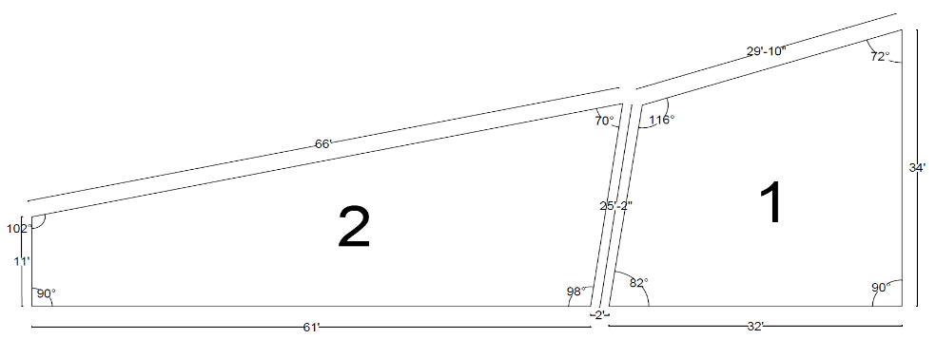

Figure 10: Design Infiltration Basins

## SLUDGE LINE (SOLID)

### Drying beds

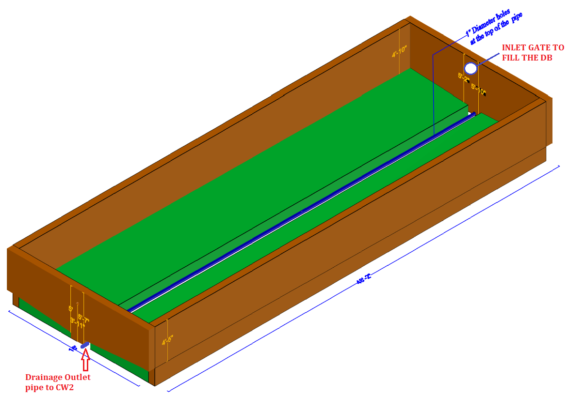

Figure 11: Drawing of the functioning of a standard drying bed (empty)

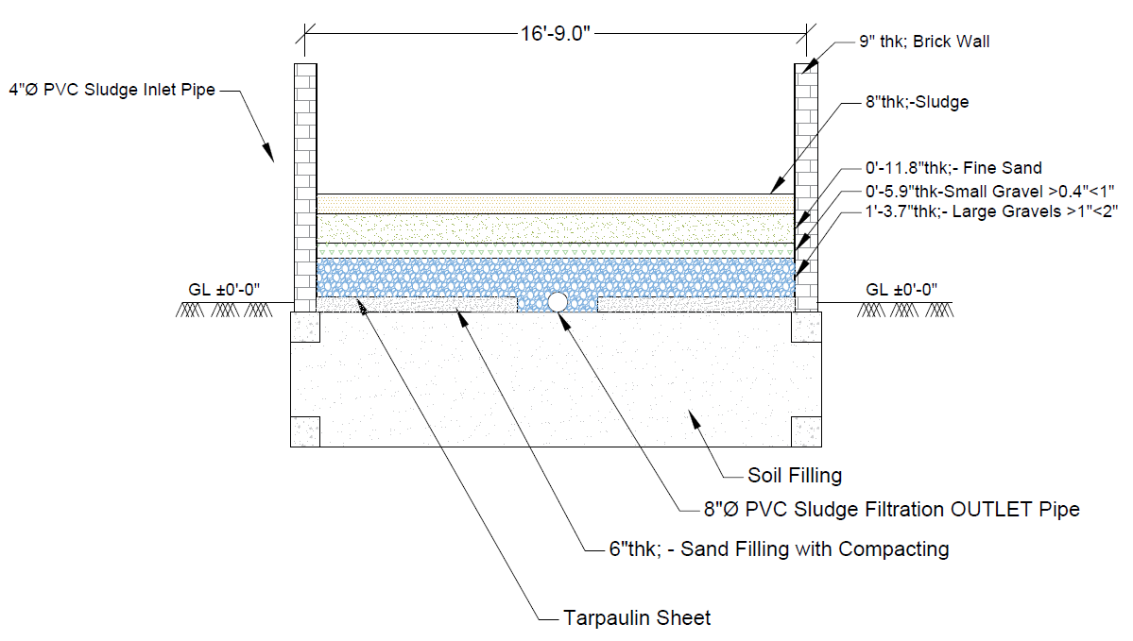

Figure 12: Drawing - Section view of a standard drying bed (Full of sludge)

The drying beds are the first module of the STS sludge treatment line. They are shallow unplanted filter beds with media consisting of sand and gravels. An underdrain pipe at the bottom of the beds collects the leachate which is conveyed to the next treatment module. Sludge from the HBT (and from other modules when they are desludged: dumping station, ABR, CW and maturation ponds) is discharged onto the surface for dewatering. The drying process is based on drainage of liquid through the sand and gravels to the bottom of the bed and evaporation of water from the surface of the sludge to the air. The leachate is then directed to a horizontal flow constructed wetland. After reaching the desired dryness, the sludge is removed from the bed manually.

### Dried sludge storage

This is the fourth module of the sludge treatment line of the STS. The sludge from the drying beds is stored to further dry.

### Incinerator

This is the fifth module of the sludge treatment line of the STS. The sludge is incinerated and the ashes are given to farmers as amendment.



Figure 13: 3D View of Incinerator

## SLUDGE LINE (LIQUID)

### Secondary constructed wetland

The secondary constructed wetland is the second module of the sludge treatment line of the STS. It treats the leachate from the sludge drying beds. It is the same module as the horizontal constructed wetlands.

### Infiltration trenches 2

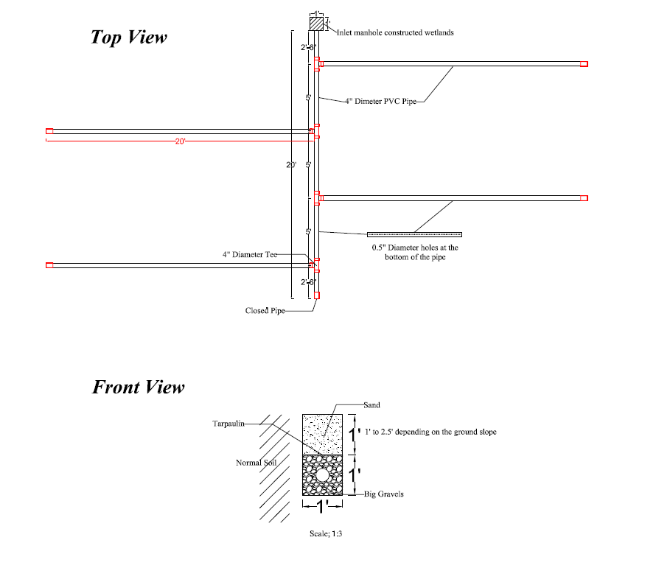

Figure 14: Drawing of the functioning of standard infiltration trenches

It is the third module of the sludge treatment line of the STS. The wastewater infiltrates into the ground through infiltration pipes settled into trenches filled with gravels.

# Operation

## General

Opening hours: 8am-5pm  
Lunch break, 2 shifts: 12am to 1pm/ 1pm to 2pm

Human resource  
One STS agent and 9 STS workers: From Monday to Thursday, one agent and 9 workers, from Friday to Saturday, one agent and 4 or 5 workers.   
A sanitation agent replaces the STS agent for his weekly day off.   
One sanitation supervisor for supervision of the STS and desludging activities.  
Watchmen day and night

Record keeping:  
A logbook used to be kept in the STS to record all maintenance and upgrade works done in the STS.  
Weekly operation sheets are filled by the STS officer to record all the operation tasks done in the STS:

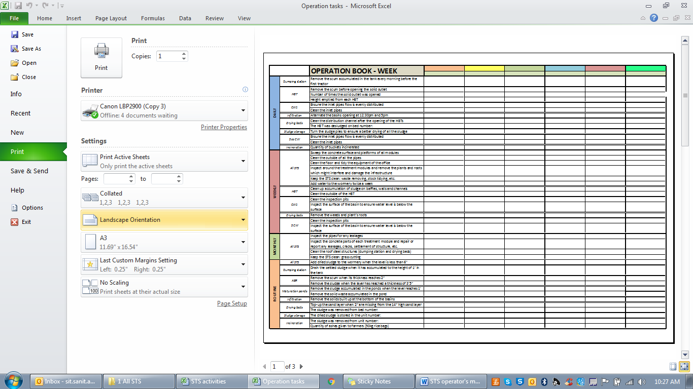

Figure 15: Logbook in STS

## Operation and maintenance procedures

**General**

|  |  |
| --- | --- |
| **Time interval** | **Tasks** |
| Weekly operation | • Sweep the concrete surface and platforms of all modules  • Clean the outside of all the pipes  • Clean the floor and tidy the equipment of the office  • Inspect around the treatment modules and remove the plants and roots which might interfere and damage the infrastructure  • Keep the STS clean: waste removing, stock tidying, etc.  • Add water to the wormery twice a week |
| Monthly operation | • Inspect the pipes and repair any leakages  • Inspect the concrete parts of each treatment module and repair or report any leakages, cracks, settlement of structure, etc.  • Keep the STS clean: waste removing, grass cutting  • Clean the roof steel structures (dumping station and drying beds) |
| Routine operation | • Add dried sludge to the wormery when the level is less than 6" |
| Annual maintenance | • Clean the external walls and slab of the modules either with a high pressure hose or with a brush and water  • Control the corrosion on the metal parts: scrap rust, paint metal surfaces, repair corroded concrete reinforcement  • Apply one coat of water paint and two coats of quality gloss paint on the metal parts to avoid corrosion  • Apply a coat of paint on the external PVC pipes to protect them from weathering |

### Dumping station

The tractors climb up the ramp backward and reach the dumping station. The tank is emptied in one of the reception tanks by opening the ball valve (figure 16). Two tractors can be emptied in parallel in the two reception tanks. The volume of sludge transported is measured in the tank, which is then opened by a gate valve (figure 16). The volume is recorded in “Monitoring WIDE” report and “Lab analysis”.

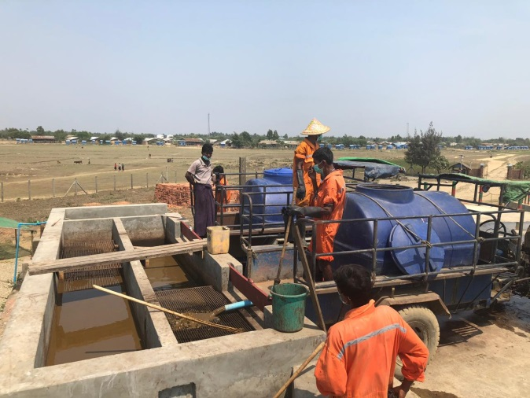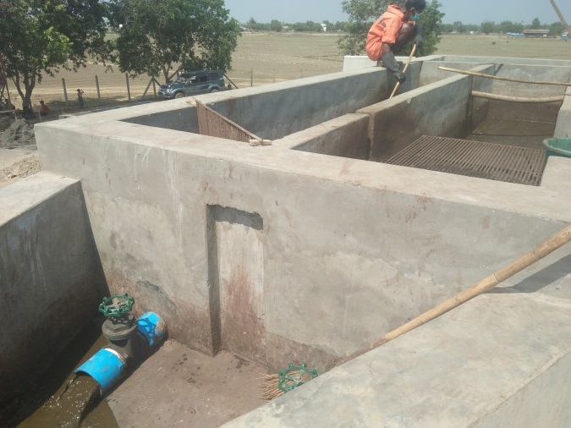

Figure 16: Emptying of tractors in the Dumping Station & Emptying of the reception tanks

**Operation and maintenance procedures**

|  |  |
| --- | --- |
| **Time interval** | **Tasks** |
| Daily operation | • Remove the scum accumulated in the tank every morning before the first tractor |
| Routine operation | • Clean the screen grids from all solids accumulated: the solid sludge is disposed of in the drying beds, the solid waste is incinerated separately from the dried sludge  • Drain the settled sludge when it has accumulated to the height of 1’ in the tank |

**Troubleshooting**

|  |  |
| --- | --- |
| **Problems** | **Solutions** |
| Outlet pipes clogged | Open totally the gate valve (11 turns of the handle)  Hit inside the pipe with a bamboo stick, through the Y  Use the water pump to put pressured water |
| Accident with a tractor | Contact the owner to repair the damages caused in the STS |

### Hopper Bottom tank

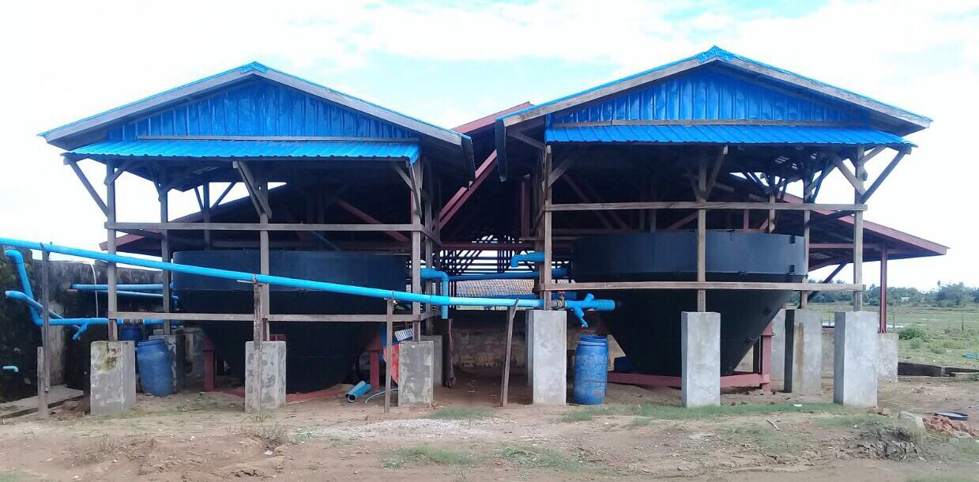

Figure 17: Hopper Bottom Tanks

|  |
| --- |
|  |

The two HBT are running in parallel. Only one HBT will be running in case of a problem or maintenance on the other one.

For each HBT, the sludge outlet pipe is opened once a day in the morning, before the first tractor has been emptied in the dumping station. Depending on the expected number of tractors coming to the STS, the sludge outlet pipe is opened again after 15, 30 and 45 tractors have arrived to the STS (see operation and maintenance procedures below).

The scum is removed manually every morning (Figure 18) and disposed of in the drying beds.

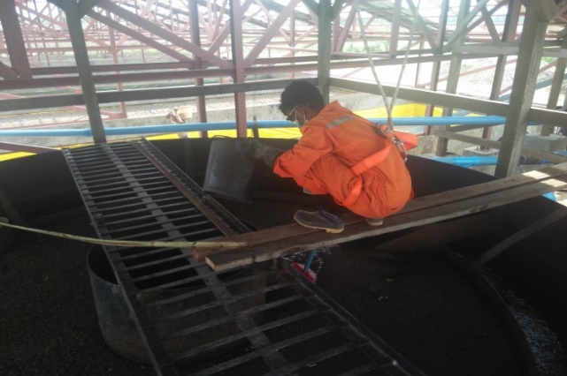

Figure 18: Scum Removal in HBT

**Operation and maintenance procedures**

|  |  |
| --- | --- |
| **Time interval** | **Tasks** |
| Daily operation | • The quantity of sludge to be extracted per day is depending on the number of tractors coming to STS:   |  |  |  |  |  | | --- | --- | --- | --- | --- | |  | Morning extraction | Extraction after 15 tractors | Extraction after 30 tractors | Extraction after 45 tractors | | Less than 20 tractors | x |  |  |  | | Between 20 and 35 tractors | x | x |  |  | | Between 35 and 50 tractors | x | x | x |  | | Between 50 and 65 tractors | x | x | x | x |   The table below gives the level to be drained in each HBT for each extraction, depending on the number of HBT running.   |  |  |  | | --- | --- | --- | |  | 1 HBT running alone | 2HBT in parallel | | Level to be drained | 7" | 4" |   Close the HBT inlet during the opening phase.  • Remove the scum every morning before opening the solid outlet and dispose of it in the drying beds  • Clean the inlet and outlet liquid pipes |
| Weekly operation | • Clean up internal builds up of sludge on baffles, walls and channels  • Clean the outside of the HBT  • Ensure the inlet flows are equal |
| Bi-annual maintenance | • Empty totally both HBT  • Every year Paint inside HBT with anti-corrosive paint |

**Troubleshooting**

|  |  |
| --- | --- |
| **Problems** | **Solutions** |
| It is not possible to remove the scum in the inlet cylinder box: it is not accessible because of the bridge | Not an issue. It is automatically partially removed when doing desludging |
| The solid outlet HBT pipe has no flow coming because of pipe or valve blockage | Remove and clean the valve/pipe |
| The inlet flow is not equal in HBT1 and HBT2 | Adjust the gate valves opening by turning it |

### Anaerobic Baffled Reactor

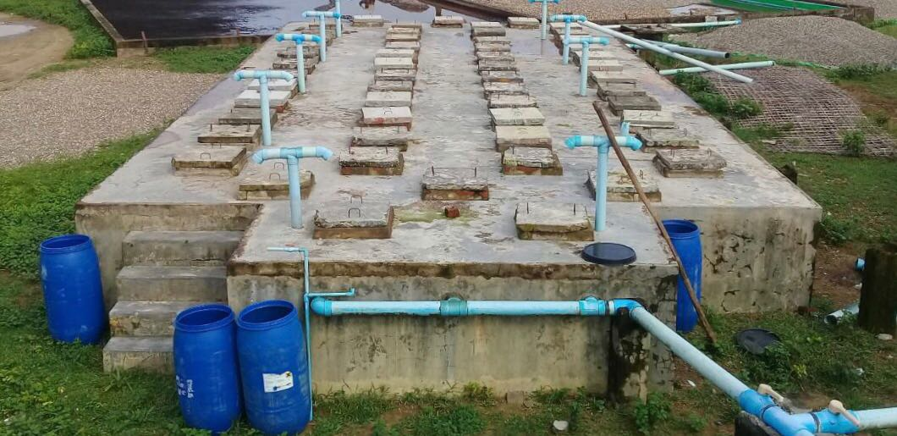

Figure 19: Anaerobic Baffled Reactor

The wastewater is coming from the HBT in discontinuous flow.

**Operation and maintenance procedures**

|  |  |
| --- | --- |
| **Time interval** | **Tasks** |
| Routine operation | • Remove the scum when its thickness reaches 2”  • Remove the sludge when the layer has reached a thickness of 3’6”: remove all the sludge in the chambers 1 and 2 (inspection twice a week), leave a minimum of 1’8” layer of sludge in the chambers 3 to 10 (monthly inspection), and 1’ in the other chambers without gravels  • Remove the sludge when water pass through the by-pass (upward) |
| Bi annual maintenance | • Remove the sludge in the chambers with gravels |
| Every 5 years maintenance | • Wash the filter media in the chambers with gravels (See ABR cleaning SOPs) |

**Troubleshooting**

|  |  |
| --- | --- |
| **Problems** | **Solutions** |
| Leakage from the outlet pipe | Change the pipe or remake the glue connection |
| Pipes inside the ABR get clogged | Hit the inside of the pipe with a bamboo stick |

### Constructed wetlands 1

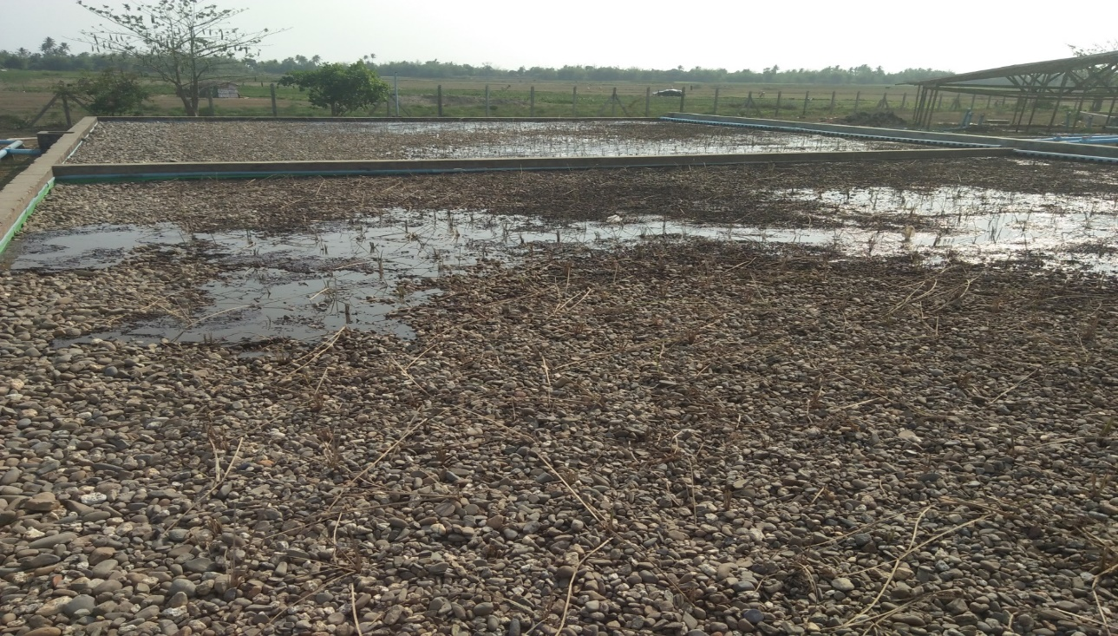

Figure 20: Constructed wetlands (The two beds run in parallel)

|  |
| --- |
|  |

**Operation and maintenance procedures**

|  |  |
| --- | --- |
| **Time interval** | **Tasks** |
| Daily operation | • Ensure the inlet pipes flow is evenly distributed  • Clean the inlet pipes |
| Weekly operation | • Clean the inspection pits |
| Routine operation | • Remove the solid sludge on the surface when the flow is making a drainage |
| Every 5 years maintenance | • Replace or wash the filter media when it is clogged or when efficiency is reduced (See CW cleaning and planting SOPs) |

**Troubleshooting**

|  |  |
| --- | --- |
| **Problems** | **Solutions** |
| Surface sludge | The hard part is removed by hand, the liquid part is removed by motor pump into the maturation ponds |
| Concrete walls leakage | Plastering of the leaks |
| Outlet pipe clogged | Use the water pump to put pressured wastewater from the stabilization pond |
| Uneven distribution of the inlet pipes | Improve the leveling of the distribution pipes with the level measurement tool |

### Maturation ponds

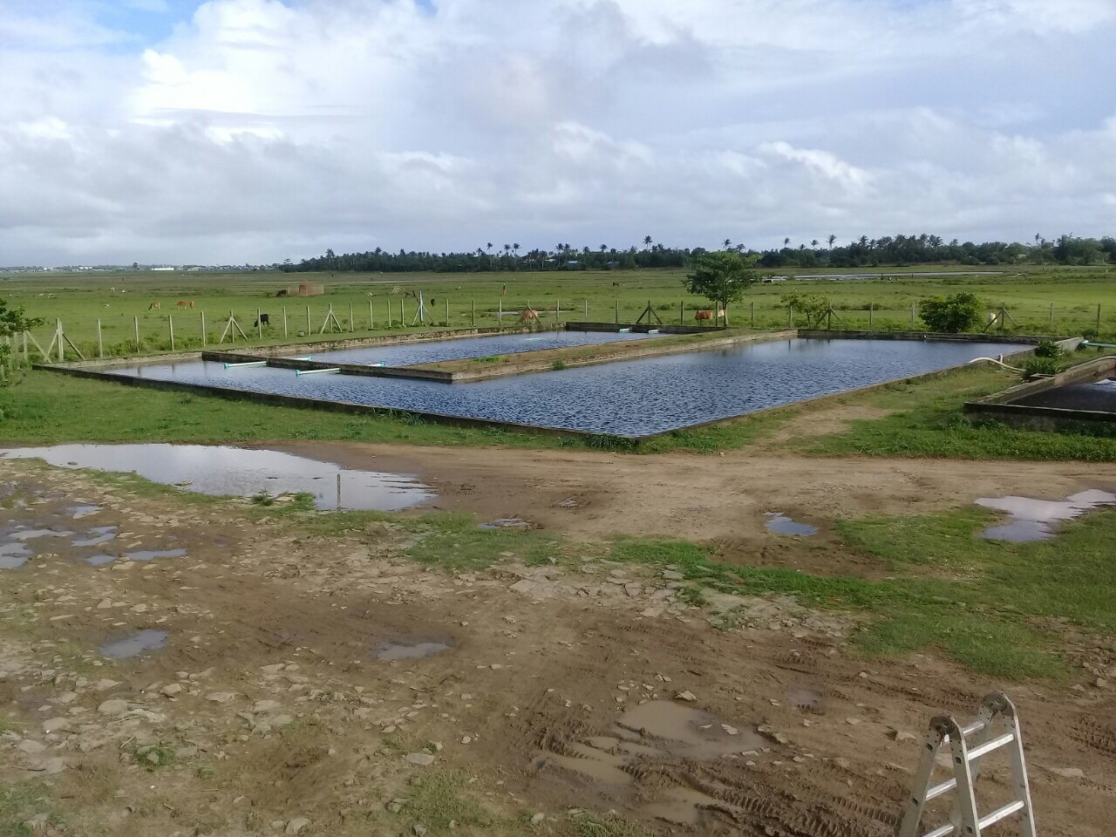

Figure 21: Maturation Ponds

The two ponds are used in series. The quantity of sludge inside the ponds can be measured thanks to the sludge measuring tool and the boat.

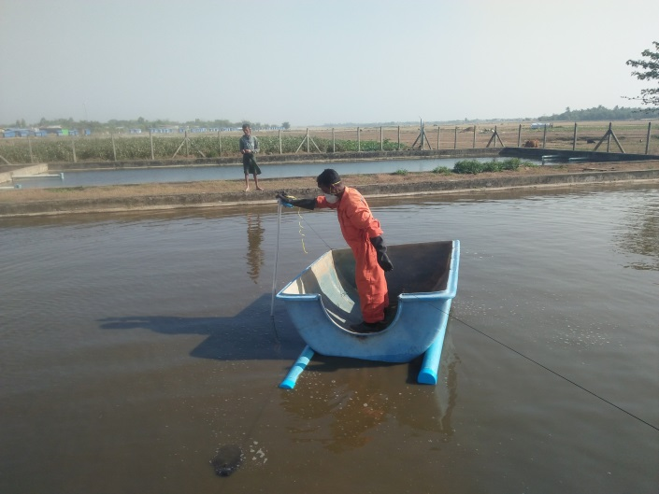

Figure 22: Measuring of the quantity of sludge accumulated

**Operation and maintenance procedures**

|  |  |
| --- | --- |
| **Time interval** | **Tasks** |
| Routine | • Remove the sludge accumulated in the ponds when the level reaches 1’ (See Maturation pond desludging SOPs)  • Remove the solid waste accumulated on the pond |

**Troubleshooting**

|  |  |
| --- | --- |
| **Problems** | **Solutions** |
| Concrete walls leakage | Plastering of the leaks |

### Infiltration basins

The two basins are used alternatively.

**Operation and maintenance procedures**

|  |  |
| --- | --- |
| **Time interval** | **Tasks** |
| Daily | • Alternate the basins opening at 12:30pm and 5pm |
| Routine | • Remove the solids built up at the bottom of the basins |

**Troubleshooting**

|  |  |
| --- | --- |
| **Problems** | **Solutions** |
| Overflowing | If it is in the rainy season, cover the basins with tarpaulin. |

*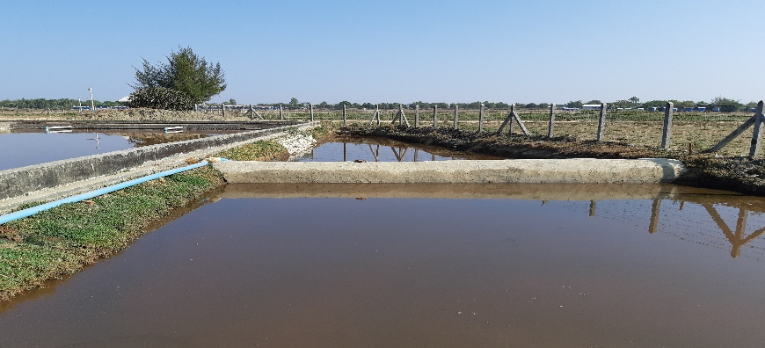*

Figure 23: Infiltration bassins (Full)

### Drying beds

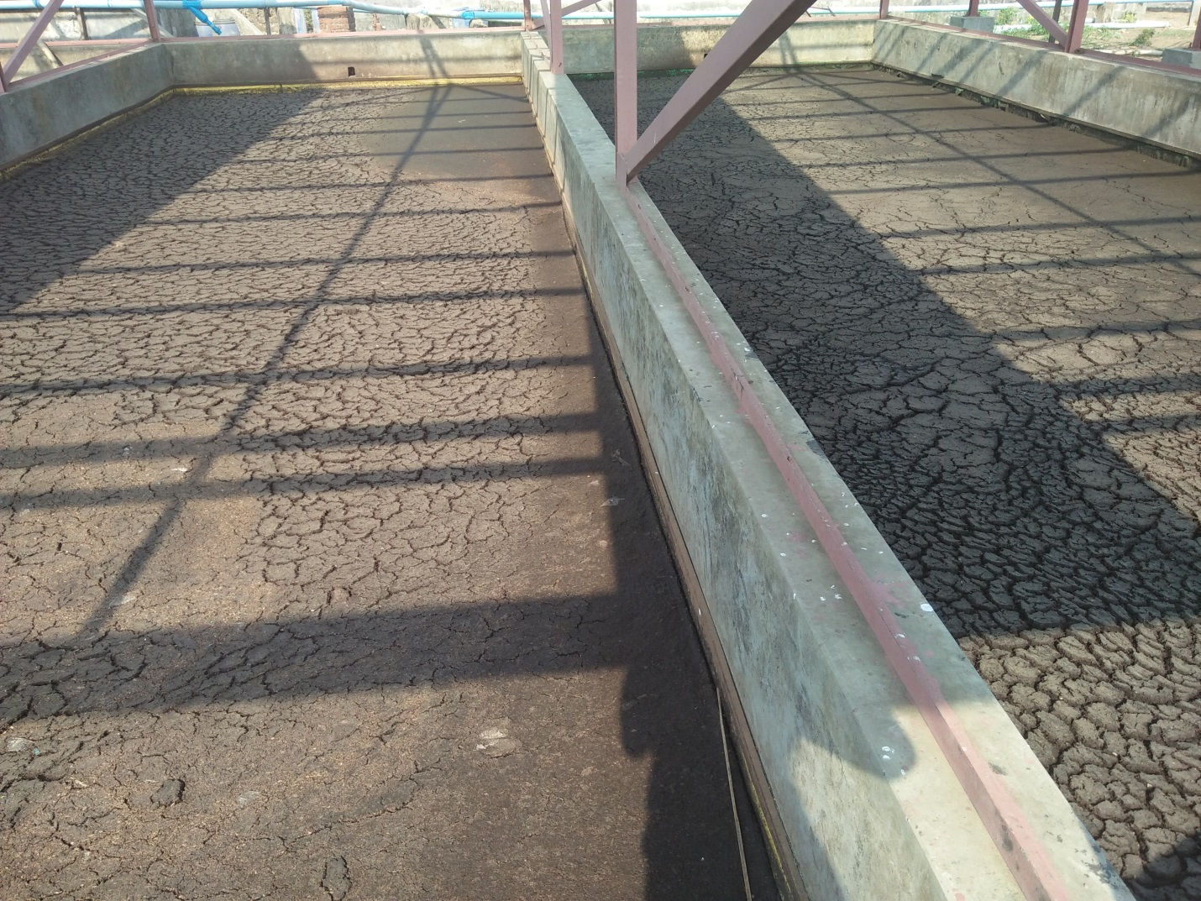

Figure 24: Unplanted Drying Beds

The beds are alternatively receiving sludge from the HBT (or from other desludging operation in the STS). The sludge goes through an open channel to the drying beds.

One bed is filled for around 5 days and then is left to dry for around 3.5 weeks (one drying cycle). The dry sludge is then manually removed by four or five workers (Figure 25), and transported to the drying area with open buckets and pushcarts (Figure 25). The leachate is collected at the bottom of the beds and diverted to the secondary constructed wetland.

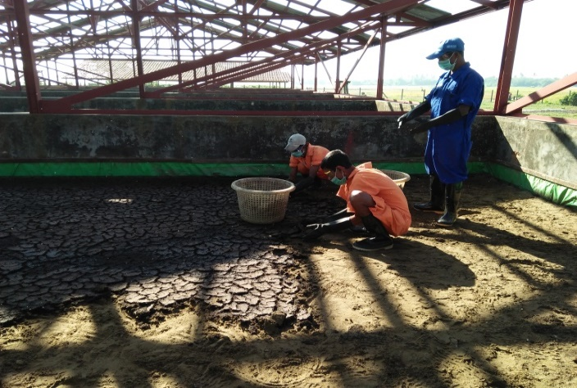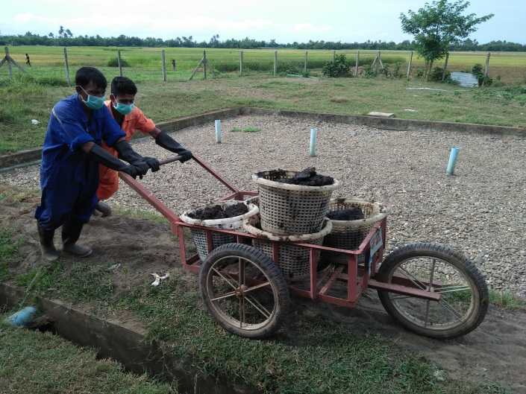

Figure 25: Workers removing and transporting dry sludge to Storage

**Operation and maintenance procedures**

|  |  |
| --- | --- |
| **Time interval** | **Tasks** |
| Daily operation | • Clean the distribution channel after the opening of the HBTs |
| Weekly operation | • Remove the weeds and plant’s roots |
| Routine operation | • Select an empty bed and fill it for several consecutive days until its level reaches 8”.  • When the sludge is dry enough to be removed (maximum 4 weeks), remove it manually without removing sand. Report any damage/holes on the Tarpaulin.  • The rotation of sludge drying beds have to be managed in order to always have a bed available before the previous bed filling phase is finished.  • Top-up the sand layer when 2” are missing from the 14” high sand layer. The fresh water sand has to be previously cleaned with clean water. |
| Bi annual maintenance | • Remove the roof after the rainy season, and put it back before the first rains |
| 5 years maintenance | • Replace or wash the filter media when it is clogged or when efficiency is reduced (See Drying beds cleaning SOPs).  • Patch the holes in the Drying Beds (Tarpaulin) or change it if needed. Make sure the Tarpaulins are correctly fixed to the walls. |

**Troubleshooting**

|  |  |
| --- | --- |
| **Problems** | **Solutions** |
| Workers are bitten by insects | Properly wear PPE Engine oil on gloves and boots (less insect but the workers are still being bitten)  Mosquito repulsive and using rakes didn’t work |

### Secondary constructed wetland

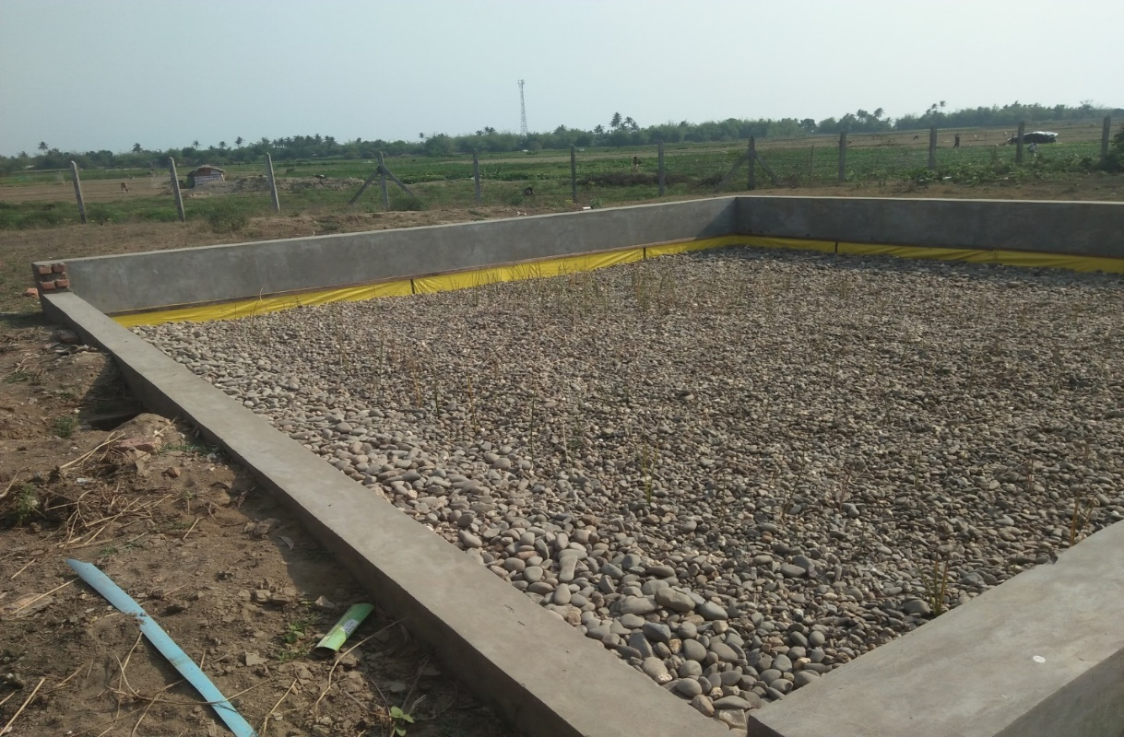

Figure 26: Secondary Constructed Wetland

**Operation and maintenance procedures**

|  |  |
| --- | --- |
| **Time interval** | **Tasks** |
| Daily operation | • Ensure the inlet pipes flow is evenly distributed  • Clean the inlet pipes |
| Weekly operation | • Clean the inspection pits  • Inspect the surface of the basin to ensure water level is below the surface (no saturation) |
| Every 5 years maintenance | • Replace or wash the filter media when it is clogged or when efficiency is reduced (See CW cleaning and planting SOPs) |

**Troubleshooting**

|  |  |
| --- | --- |
| **Problems** | **Solutions** |
| Surface sludge | The hard part is removed by hand, the liquid part is removed by motor pump |
| Uneven distribution of the inlet pipe | Improve the leveling of the distribution pipes with the level measurement tool |

### Infiltration trenches

**No operation or maintenance performed.**

**Troubleshooting**

|  |  |
| --- | --- |
| **Problems** | **Solutions** |
| Overflowing | Inspect the trenches (pipes, tarpaulin, media) and rehabilitate if necessary |

### Dried sludge storage

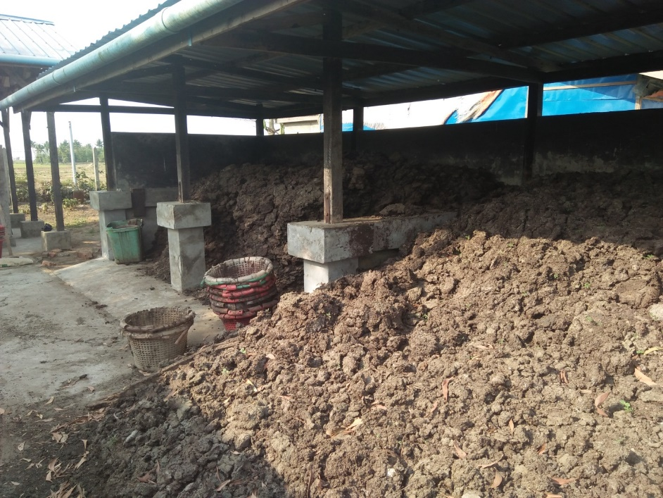

Figure 27: Dried Sludge Storage Units

The dried sludge from the drying beds is stored to further dry, until it can be incinerated. One unit can store dried sludge from 1 to 2 drying beds.

**Operation and maintenance procedures**

|  |  |
| --- | --- |
| **Time interval** | **Tasks** |
| Daily operation | • Turn the sludge piles to ensure a better drying of all the sludge |
| Routine operation | • Select an empty storage unit and fill it for several consecutive days until it is full. |

### Incineration

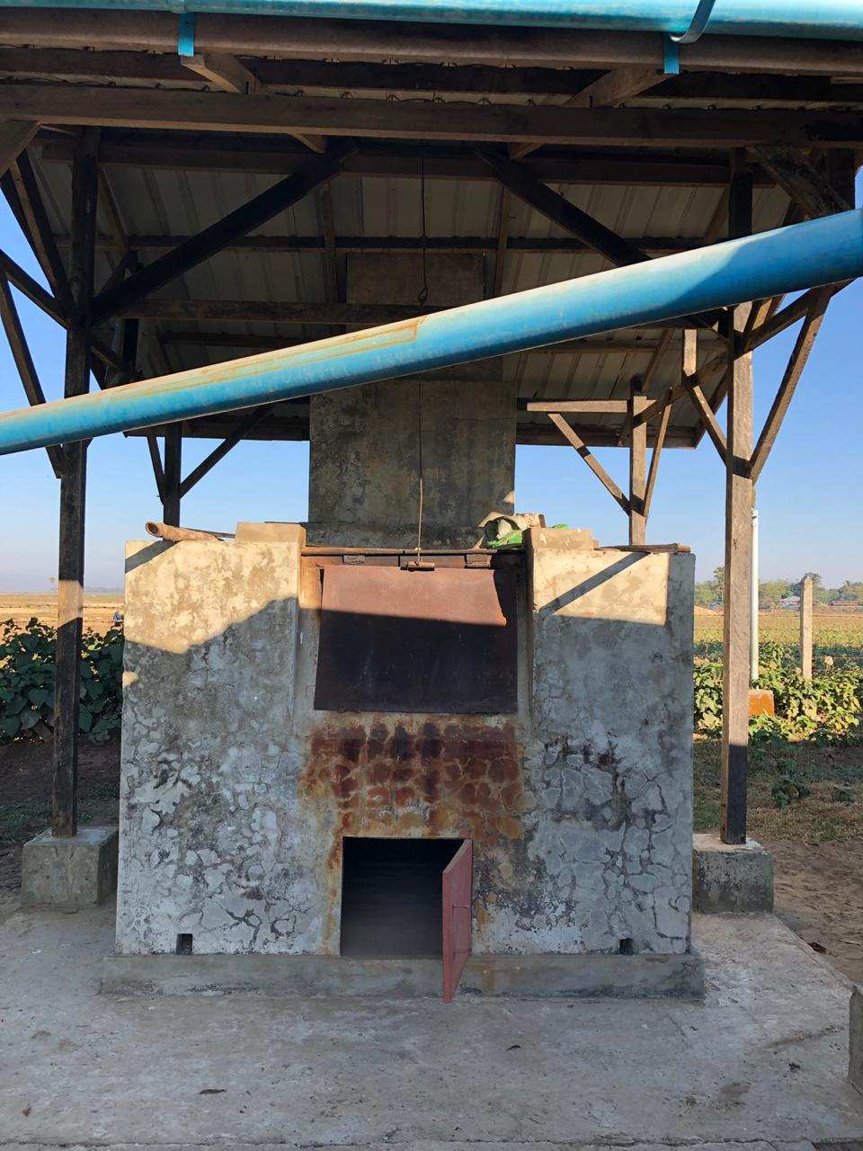

Figure 28: Incinerator

The ashes from the incineration of the sludge are stored near it meant to be given to the farmers but they don’t accept it.

**Operation and maintenance procedures**

|  |  |
| --- | --- |
| **Time interval** | **Tasks** |
| Routine operation | • The fire is started with broken tires, rubber and wood pieces.  • Incineration:  Fill the incinerator with the oldest dried sludge, for a quantity of about 40 buckets per day, 6 days/week. Remove the ashes and clean the incinerator after each operation. Store the ashes in the storage unit dedicated to it.  • The rotation of storage units has to be managed in order to always have a unit available before the previous unit filling phase is finished. |

# Monitoring plan

All the information is recorded through Survey CTO and is gathered in the document Analyses STS.

## Analysis planning

|  |  |  |  |  |  |  |  |
| --- | --- | --- | --- | --- | --- | --- | --- |
|  | TS (g/l) | TSS (mg/l) | COD (mg/l) | NH4 (mg/l) | NO3 (mg/l) | P (mg/l) | E. Coli (nb/ml) |
| Inlet HBT | 3/week |  | 1/week |  |  |  |  |
| Outlet liquid HBT | 3/week |  | 1/week | 1/week | 1/week | 2/month |  |
| Outlet solid HBT (morning, 15, 30 tractors) | 3/week |  |  |  |  |  |  |
| Outlet ABR | 2/month |  | 2/month | 2/month | 2/month |  |  |
| Inlet maturation ponds |  | 2/month | 2/month | 2/month | 2/month |  |  |
| Outlet STS |  | 1/week |  |  |  |  | 2/month |
| Outlet STS filtered |  |  | 1/week | 1/week | 1/week | 2/month |  |
| Inlet secondary constructed wetland |  | 2/month | 2/month | 2/month | 2/month |  |  |
| Outlet secondary constructed wetland |  | 1/week | 1/week | 1/week | 1/week | 2/month | 2/month |
| Dried sludge from drying beds | When removed from a drying bed |  |  |  |  |  |  |
| Dried sludge from storage  (for Incineration) | 1/week |  |  |  |  |  |  |
| ABR sludge | When the first and second chambers of the ABR are desludged |  |  |  |  |  |  |

## 

## Sampling instructions

|  |  |
| --- | --- |
| Collection point | Instructions |
| HBT inlet | Take the sample from the HBT 1, when a tractor is emptying the barrels (starting from the second tractor of the day). Let the volume trapped in the Y pipe be drained first. |
| HBT outlet liquid | Take the sample from the HBT 1 after 1pm. Let the volume trapped in the Y pipe be drained first. |
| HBT outlet solid | Take the sample from the HBT 1 during the desludging phase of the HBT. Let the volume trapped in the pipe be drained first. |
| Outlet ABR | Anytime, when there is flow. |
| Inlet maturation pond | Anytime, when there is flow. |
| STS outlet | Anytime, when there is flow. |
| STS outlet FILTERED | Anytime, when there is flow. |
| Inlet wetland II | Take the sample after 1 pm. |
| Outlet wetland II | Anytime, when there is flow. Remove the water from the pit before taking the sample. |
| Dried sludge from drying beds | When the dried sludge is removed from a drying bed. |
| Dried sludge from storage unit | Take a sample from one of the bucket incinerated. |
| ABR sludge | At the outlet of the pump. |

Pathogens E.Coli: Fill half of a one-liter sample and send it to Oxfam lab before 1pm the same day. Label the bottles.

## Other data monitored

Every day:

* + - * Tractor number
* Tractor arrival time
* Camp name
* Organization
* Volume of sludge transported
* The HBT was desludged to the bed number
* Level of sludge in the six beds: report the level of the sludge reached on the wooden measurement tool.
* Daily sum of total sludge discharged at the STS (see Analysis Lab report)

Once a week:

* Sludge quantity in the first two chambers of the ABR: to measure with the sludge measurement tool.

Once a month:

* Sludge quantity in all chambers of the ABR: to measure with the sludge measurement tool.

When necessary:

* In which bed sludge is removed
* At which incinerator chamber sludge is stored
* In general, the approximate volume of sludge (Barrel quantity for instance) which is being removed either from ABR, Maturation Pond…in order to check the volume of sludge that should be removed from HBT.

For each Sludge Drying Bed:

* The quantity/quality of sludge at the beginning and at the end of each cycle for each drying bed and duration of this cycle (see Drying cycles of drying beds report).

The farmer’s information is recorded and kept at the STS when ashes are taken:



# Health and Safety

## Health and safety measures

1. Wearing boots, gloves, glasses, boiler suits and masks is mandatory during work activities at STS
2. The STS officer should report any damaged equipment and ensure its replacement
3. Wounds should be covered with clean, dry, waterproof bandages
4. Boots, gloves and glasses have to be cleaned with chlorine after the end of the working day
5. Boiler suits should be soaked for 10 minutes in chlorine solution, before being washed with water and laundry soap, once a week
6. Masks have to be thrown away after one week of use
7. All protective equipment has to be properly dried and stored in the shower house
8. It is forbidden to wear the protective equipment outside the work environment
9. It is forbidden to smoke, chew betel, tobacco or gum during working time
10. Eating on the dumping station is forbidden
11. The gloves should be cleaned with chlorine and water between tractors
12. In case of contact with sludge, the skin should be washed thoroughly with soap and water, and the eyes flushed thoroughly
13. In case of getting sprayed or soaked down with sludge, the clothes have to be changed and the skin cleaned with soap and water – a shower should be taken if necessary
14. The hands should be thoroughly washed with soap and water after removing the PPE, and before eating, drinking and smoking
15. A shower with soap must be taken and clothes must be changed before leaving work - before lunch and at the end of the day
16. The safety harness has to be worn when operating on Hopper Bottom Tanks
17. The mask with particle filter has to be used during incineration process
18. The STS workers shouldn’t enter the incinerator when starting the fire

## Security measures

1. Only the following employees are **authorized to enter the STS office**:
   1. SI agents
   2. SI officers
   3. SI supervisors
   4. SI activity managers
   5. SI managers
   6. SI field coordinator
   7. SI human resources and finance department employees
2. The following persons are **not authorized to enter the office**, unless expressively asked by a manager, and always in the presence of the person in charge of the office at the moment:
   1. SI STS workers
   2. SI watchman
   3. SI daily workers
   4. Employees from other organizations
   5. Visitors
3. The STS office has to be systematically locked (doors and windows) when the STS agent (or sanitation agent in case of absence of the STS agent) leaves the office.
4. The STS officer is responsible for the office key management and has to inform his line manager in case of any issue.
5. Any employee who witnesses a breaking of the rules has to inform one of SI managers directly.

**In case of non-respect of these rules, disciplinary measures will be taken.**